Author : Ndiouga Benga
École de Dakar
L'École de Dakar is a movement of artistic revival born in Senegal at the beginning of independence, encouraged by President Léopold Sédar Senghor (1960-1980). Senghor’s project of "a new art for a new nation" was implemented by practitioners and teachers such as Iba Gustave Ndiaye (1928-2008), Papa Ibra Tall (1935-) and Pierre André Lods (1921-1989), founder of L'École de Poto-Poto, in Brazzaville, in 1951. Born in the School of Arts based in Dakar in 1960, it included a visual arts section and a black plastics arts research section in 1961, to which carving and tapestry were added in 1963 and 1964. L'École de Dakar asserted itself at the First World Festival of Black Arts held in Dakar in 1966 and dominated the life of the plastic arts in Senegal until 1980. Through an abundant artistic production presented at the Salon de Dakar, exhibitions abroad and a recognisable style (plenty of features, lines, signs and symbols, cubic, square and rectangular shapes) some forty artists (including three women) including Ibou Diouf, Bocar Pathé Diongue, Abdoulaye Ndiaye, Amadou Ba, Diatta Seck, Souleymane Keita, and Ansoumana Diedhiou trained during the sixties and the seventies. The École de Dakar contributed to the modern arts of Senegal as witness of a new art for a new nation, a label in the expression of Africanness at home and abroad.
The work produced by the members of the school reflected on the values ​​of precolonial Africa with themes related to representations of masks and statues, minds and spirits, authentic and old values ​​of the black world, and was inspired by the ideology of Négritude (rootedness and openness). They told, in a cosmopolitan way, the tales of important Senegalese and Panafrican, historical, political, cultural and religious heroes or commented on spiritual and ritual forces at work. The art did not imitate reality but favoured and generated suggestions, significant details and sketches that showed essence instead of presenting reality. It was also open to techniques and modern tools of creation, to the fertilising contributions of other peoples. L'École de Dakar has been marked by the omnipresence of Léopold Sédar Senghor in terms of orientation and patronage on the one hand and on the other hand by options and tensions of its animators. L’École de Dakar has been the subject of a lot of criticism and ultimately lost its aura after Senghor, its most important theorist and patron, withdrew from public life.

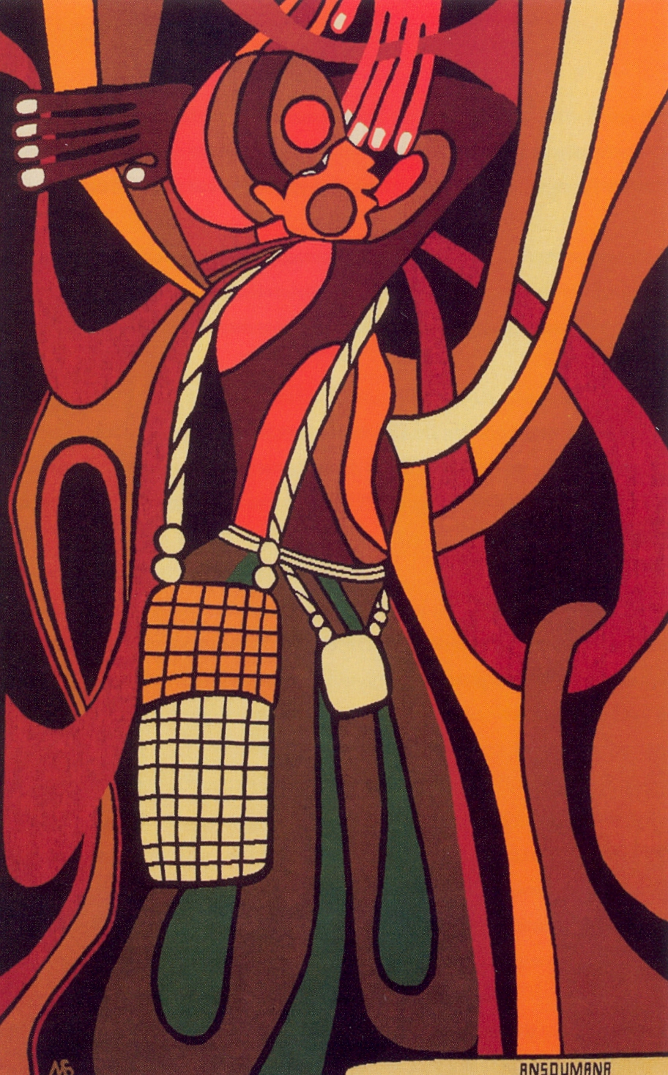

Ansoumana Diedhiou, Afankarin (the sacred wood wise man), 1980, tapestry, in Sylla, A., Seck, S. and Mbaye, M. (eds.) (unknown date) Une passion en couleurs. Art contemporain du Sénégal, collection de Abdoulaye Diop et de Fatoumata Sow, Dakar: Imprimerie du Midi, p. 43
References and further reading
Samb, I. (2013) « The Painters of the Dakar School. Les peintres de l’Ecole de Dakar », in Kouoh, K. (ed.) (2013) Word ! Word ? Word ! Issa Samb and the Undecipherable Form. Parole ! Parole ? Parole ! Issa Samb et la forme indéchiffrable, Office for Contemporary Art Norway Oslo, Raw Material Company Dakar, Berlin: Sternberg Press : 115-121.
Seck, S. (2003) “L'École de Dakar, réalité historique ou escroquerie intellectuelle?”, Ethiopiques 70 (1): 29-45.
Senghor, L. S. (1964) Liberté I. Négritude et Humanisme, Paris: Seuil.
Snipe, T. (1998) Arts and Politics in Senegal 1960-1996, Asmara-Trenton: Africa World Press.
Sylla, A. (1998) Arts plastiques et Etat au Sénégal. Trente-cinq ans de mécénat au Sénégal, Dakar: Institut Fondamental d’Afrique Noire-Cheikh Anta Diop.
Sylla, A., Seck, S. and Mbaye, M. (eds.) (unknown date) Une passion en couleurs. Art contemporain du Sénégal, collection de Abdoulaye Diop et de Fatoumata Sow, Dakar: Imprimerie du Midi.

